Министерство образования Республики Беларусь

Учреждение образования

БЕЛОРУССКИЙ ГОСУДАРСТВЕННЫЙ УНИВЕРСИТЕТ

ИНФОРМАТИКИ И РАДИОЭЛЕКТРОНИКИ

Факультет компьютерных систем и сетей

Кафедра информатики

Дисциплина: Методы численного анализа

**ОТЧЁТ**

к лабораторной работе

на тему

Аппроксимация граничных условий второго рода в методе конечных разностей на примере уравнения теплопроводности

Выполнил: студент группы 153501

Тимофеев Кирилл Андреевич

Проверил: Анисимов Владимир Яковлевич

Минск 2023

**Цели выполнения задания**

Ознакомиться с наиболее часто применяемыми способами аппроксимации граничных условий второго рода (граничных условий (ГУ) Неймана) в методе конечных разностей (на примере ГУ для одномерного нестационарного уравнения теплопроводности).

**Краткие теоретические сведения**

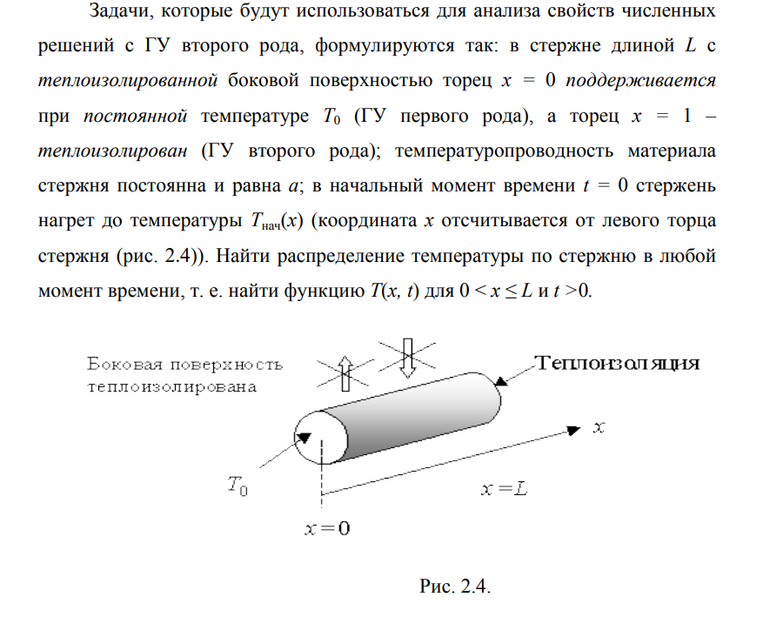

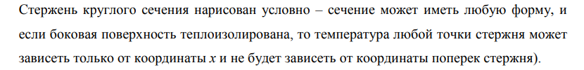



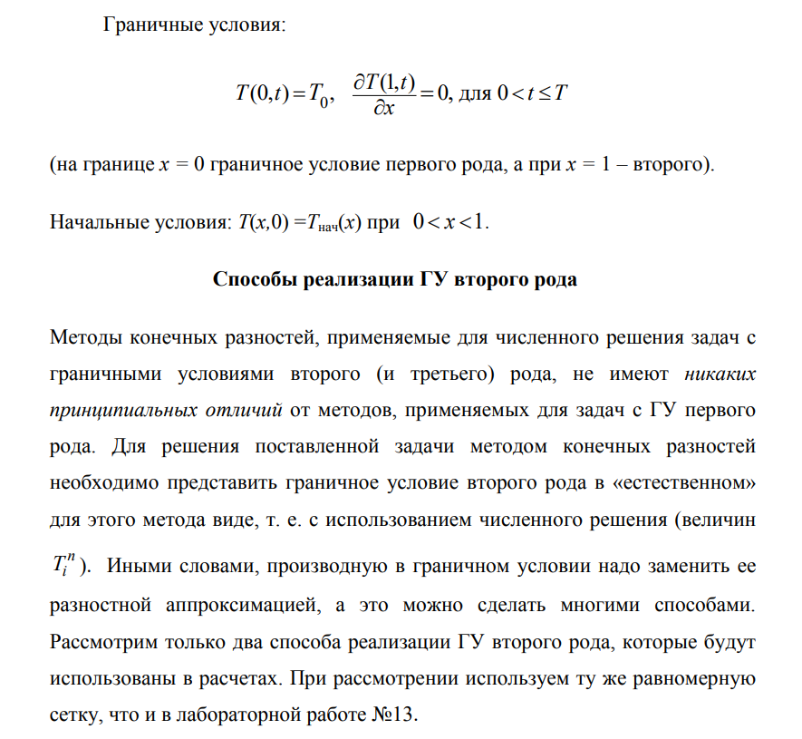

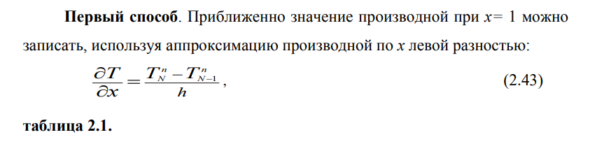

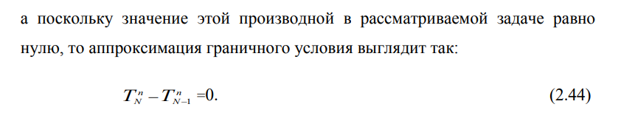

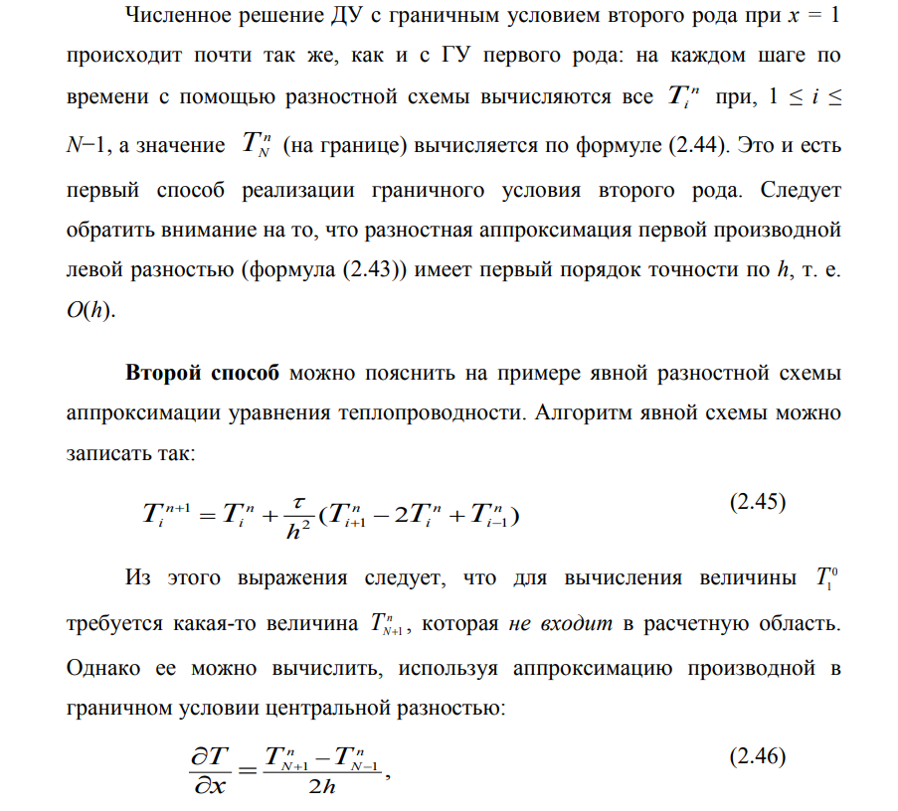

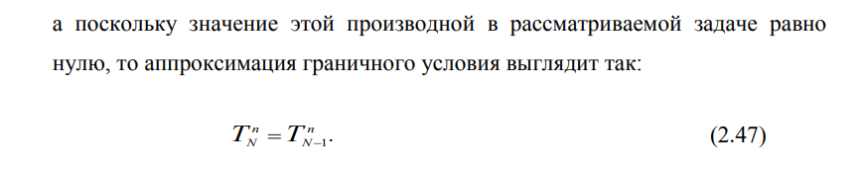

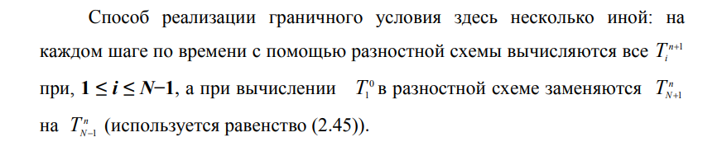

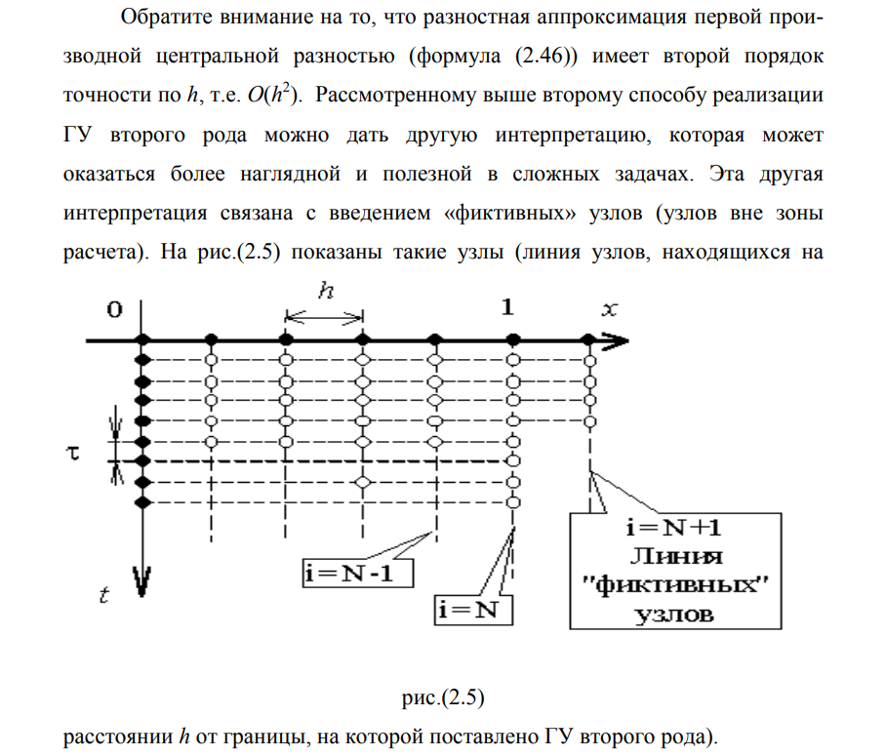

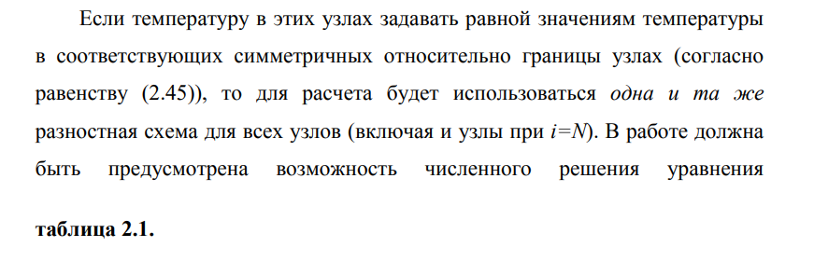

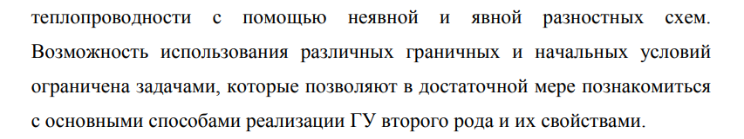

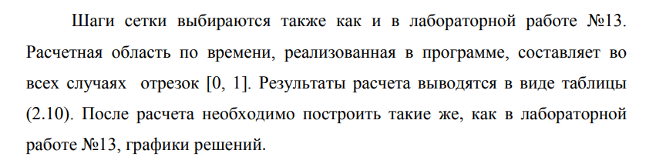

**Программная реализация**

import numpy as np

import math

from matplotlib import pyplot as plt

from scipy import integrate

from mpl_toolkits.mplot3d import Axes3D

A = -1

B = 1

k = 0.5

phi = lambda x: abs(x)

g1 = lambda t: 1

g2 = lambda t: 1

f = lambda x, t: 0

T = 0.4

def explicit_method_1(h, tau, build_plot=False):

M = int(T / tau) + 1

N = int((B - A) / h) + 1

x_values = np.linspace(A, B, N)

t_values = np.linspace(0, tau, M)

matrix = np.zeros((M, N))

matrix[0] = [phi(x) for x in x_values]

matrix[:, 0] = [g1(t) for t in t_values]

for i in range(M - 1):

for j in range(1, N - 1):

matrix[i + 1][j] = k * tau / h ** 2 * matrix[i][j - 1]

matrix[i + 1][j] += (1 - 2 * k * tau / h ** 2) * matrix[i][j]

matrix[i + 1][j] += k * tau / h ** 2 * matrix[i][j + 1]

matrix[i + 1][j] += tau * f(x_values[j], t_values[i])

matrix[i + 1][-1] = matrix[i + 1][-2] + h * g2(t_values[i])

if build_plot:

fig = plt.figure()

ax = fig.add_subplot(111, projection='3d')

for i in range(len(t_values) - 1, -2, -1000):

x = x_values

y = [i * tau] * len(x)

z = matrix[i]

ax.plot(x, y, z)

plt.show()

return matrix

def explicit_method_2(h, tau, build_plot=False):

M = int(T / tau) + 1

N = int((B - A) / h) + 1

x_values = np.linspace(A, B, N)

t_values = np.linspace(0, tau, M)

matrix = np.zeros((M, N))

matrix[0] = [phi(x) for x in x_values]

matrix[:, 0] = [g1(t) for t in t_values]

for i in range(M - 1):

for j in range(1, N - 1):

matrix[i + 1][j] = k * tau / h ** 2 * matrix[i][j - 1]

matrix[i + 1][j] += (1 - 2 * k * tau / h ** 2) * matrix[i][j]

matrix[i + 1][j] += k * tau / h ** 2 * matrix[i][j + 1]

matrix[i + 1][j] += tau * f(x_values[j], t_values[i])

matrix[i + 1][-1] = k * tau / h ** 2 * matrix[i][-2]

matrix[i + 1][-1] += (1 - 2 * k * tau / h ** 2) * matrix[i][-1]

matrix[i + 1][-1] += k * tau / h ** 2 * (2 * h * g2(t_values[i]) + matrix[i + 1][-2])

matrix[i + 1][-1] += tau * f(x_values[j], t_values[i])

if build_plot:

fig = plt.figure()

ax = fig.add_subplot(111, projection='3d')

for i in range(len(t_values) - 1, -2, -1000):

x = x_values

y = [i * tau] * len(x)

z = matrix[i]

ax.plot(x, y, z)

plt.show()

return matrix

def implicit_method_1(h, tau, build_plot=False):

M = int(T / tau) + 1

N = int((B - A) / h) + 1

x_values = np.linspace(A, B, N)

t_values = np.linspace(0, tau, M)

result = np.zeros((M, N))

result[0] = [phi(x) for x in x_values]

result[:, 0] = [g1(t) for t in t_values]

matrix = np.zeros((N, N))

for j in range(1, N - 1):

matrix[j][j - 1] = - k * tau / h ** 2

matrix[j][j] = 1 + 2 * k * tau / h ** 2

matrix[j][j + 1] = - k * tau / h ** 2

matrix[0][0] = 1

matrix[-1][-1] = 1

matrix[-1][-2] = - 1

for i in range(1, M):

b = np.array([tau * f(x, t_values[i] + tau) for x in x_values]) + result[i - 1]

b[0] = g1(t_values[i])

b[-1] = h * g2(t_values[i])

result[i] = np.linalg.solve(matrix, b)

if build_plot:

fig = plt.figure()

ax = fig.add_subplot(111, projection='3d')

for i in range(len(t_values) - 1, -2, -1000):

x = x_values

y = [i * tau] * len(x)

z = result[i]

ax.plot(x, y, z)

plt.show()

return result

def implicit_method_2(h, tau, build_plot=False):

M = int(T / tau) + 1

N = int((B - A) / h) + 1

x_values = np.linspace(A, B, N)

t_values = np.linspace(0, tau, M)

result = np.zeros((M, N))

result[0] = [phi(x) for x in x_values]

result[:, 0] = [g1(t) for t in t_values]

matrix = np.zeros((N + 1, N + 1))

for j in range(1, N):

matrix[j][j - 1] = - k * tau / h ** 2

matrix[j][j] = 1 + 2 * k * tau / h ** 2

matrix[j][j + 1] = - k * tau / h ** 2

matrix[0][0] = 1

matrix[-1][-1] = 1

matrix[-1][-3] = -1

for i in range(1, M):

b = np.zeros(N + 1)

b[1:-1] = np.array([tau * f(x, t_values[i] + tau) for x in x_values[1:]]) + result[i - 1][1:]

b[0] = g1(t_values[i])

b[-1] = 2 * h * g2(t_values[i])

result[i] = np.linalg.solve(matrix, b)[:-1]

if build_plot:

fig = plt.figure()

ax = fig.add_subplot(111, projection='3d')

for i in range(len(t_values) - 1, -2, -1000):

x = x_values

y = [i * tau] * len(x)

z = result[i]

ax.plot(x, y, z)

plt.show()

return result

def task():

h = (B - A) / 500

tau = 0.5 * (h ** 2) / k

# explicit_method_1(h, tau, build_plot=True)

# explicit_method_2(h, tau, build_plot=True)

# implicit_method_1(h, tau, build_plot=True)

# implicit_method_2(h, tau, build_plot=True)

from approximation import task

from statistics import stats

if __name__ == '__main__':

task()

stats()

from prettytable import PrettyTable

import matplotlib.pyplot as plt

import numpy as np

from approximation import explicit_method_1, explicit_method_2, implicit_method_1, implicit_method_2, A, B

variants_1 = [

# N, tau, t1, t2

[10, 0.001, 0.25, 0.3],

[10, 0.0005, 0.25, 0.3],

[10, 0.00025, 0.25, 0.3],

[10, 0.000125, 0.25, 0.3],

[10, 0.0000625, 0.25, 0.3]

]

variants_2 = [

# N, t1, t2

[10, 0.25, 0.3],

[20, 0.25, 0.3],

[30, 0.25, 0.3],

[40, 0.25, 0.3],

[50, 0.25, 0.3]

]

methods = [

[explicit_method_1, 'Explicit method #1'],

[explicit_method_2, 'Explicit method #2'],

[implicit_method_1, 'Implicit method #1'],

[implicit_method_2, 'Implicit method #2']

]

table_1 = PrettyTable()

table_2 = PrettyTable()

table_3 = PrettyTable()

table_4 = PrettyTable()

table_1.field_names = ['N', 'tau', 's(t=t1)', 's(t=t2)', 'max(t=t1)', 'max(t=t2)']

table_2.field_names = ['N', 'tau', 's(t=t1)', 's(t=t2)', 'max(t=t1)', 'max(t=t2)']

table_3.field_names = ['N', 'tau', 's(t=t1)', 's(t=t2)', 'max(t=t1)', 'max(t=t2)']

table_4.field_names = ['N', 'tau', 's(t=t1)', 's(t=t2)', 'max(t=t1)', 'max(t=t2)']

errors_t1 = []

errors_t2 = []

def stats():

for method, name in methods:

print(name)

print('_____________________________________________________________________')

for N, tau, t1, t2 in variants_1:

h = (B - A) / N

solution_1 = method(h, tau)

solution_2 = method(h, tau / 2)

err_t1 = (solution_1[int(t1 / tau)] - solution_2[2 * int(t1 / tau)])

err_t2 = (solution_1[int(t2 / tau)] - solution_2[2 * int(t2 / tau)])

errors_t1.append((tau, np.linalg.norm(err_t1)))

errors_t2.append((tau, np.linalg.norm(err_t2)))

table_1.add_row([N, tau, err_t1.std(), err_t2.std(), max(abs(err_t1)), max(abs(err_t2))])

print('h is fixed')

print(table_1)

table_1.clear_rows()

plt.xscale('log')

plt.xlabel('tau', fontsize=18)

plt.ylabel('error', fontsize=18)

plt.plot([tau for tau, err in errors_t1], [tau for tau, err in errors_t1], label='t = t1')

plt.legend()

plt.show()

errors_t1.clear()

plt.xscale('log')

plt.xlabel('tau', fontsize=18)

plt.ylabel('error', fontsize=18)

plt.plot([tau for tau, err in errors_t2], [tau for tau, err in errors_t2], label='t = t2')

plt.legend()

plt.show()

errors_t2.clear()

for N, t1, t2 in variants_2:

h = (B - A) / N

tau = 0.0001

solution_1 = method(h, tau)

solution_2 = method(h / 2, tau)

err_t1 = (solution_1[int(t1 / tau)] - solution_2[int(t1 / tau)][::2])

err_t2 = (solution_1[int(t2 / tau)] - solution_2[int(t2 / tau)][::2])

errors_t1.append((h, np.linalg.norm(err_t1)))

errors_t2.append((h, np.linalg.norm(err_t2)))

table_2.add_row([N, tau, err_t1.std(), err_t2.std(), max(abs(err_t1)), max(abs(err_t2))])

print('tau is fixed')

print(table_2)

table_2.clear_rows()

plt.xscale('log')

plt.xlabel('h', fontsize=18)

plt.ylabel('error', fontsize=18)

plt.plot([h for h, err in errors_t1], [h for h, err in errors_t1], label='t = t1')

plt.legend()

plt.show()

errors_t1.clear()

plt.xscale('log')

plt.xlabel('h', fontsize=18)

plt.ylabel('error', fontsize=18)

plt.plot([h for h, err in errors_t2], [h for h, err in errors_t2], label='t = t2')

plt.legend()

plt.show()

errors_t2.clear()

print('tau is h ^ 2 / 6 (relative to tau)')

for N, t1, t2 in variants_2:

h = (B - A) / N

tau = (h ** 2) / 6

solution_1 = method(h, tau)

solution_2 = method(h, tau / 2)

err_t1 = (solution_1[int(t1 / tau)] - solution_2[2 * int(t1 / tau)])

err_t2 = (solution_1[int(t2 / tau)] - solution_2[2 * int(t2 / tau)])

table_3.add_row([N, tau, err_t1.std(), err_t2.std(), max(abs(err_t1)), max(abs(err_t2))])

print(table_3)

table_3.clear_rows()

print('tau is h ^ 2 / 6 (relative to h)')

for N, t1, t2 in variants_2:

h = (B - A) / N

tau = (h ** 2) / 6

solution_1 = method(h, tau)

solution_2 = method(h / 2, tau)

err_t1 = (solution_1[int(t1 / tau)] - solution_2[int(t1 / tau)][::2])

err_t2 = (solution_1[int(t2 / tau)] - solution_2[int(t2 / tau)][::2])

table_4.add_row([N, tau, err_t1.std(), err_t2.std(), max(abs(err_t1)), max(abs(err_t2))])

print(table_4)

table_4.clear_rows()

**Полученные результаты**

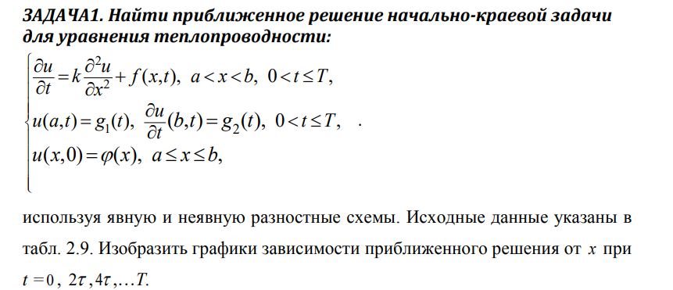





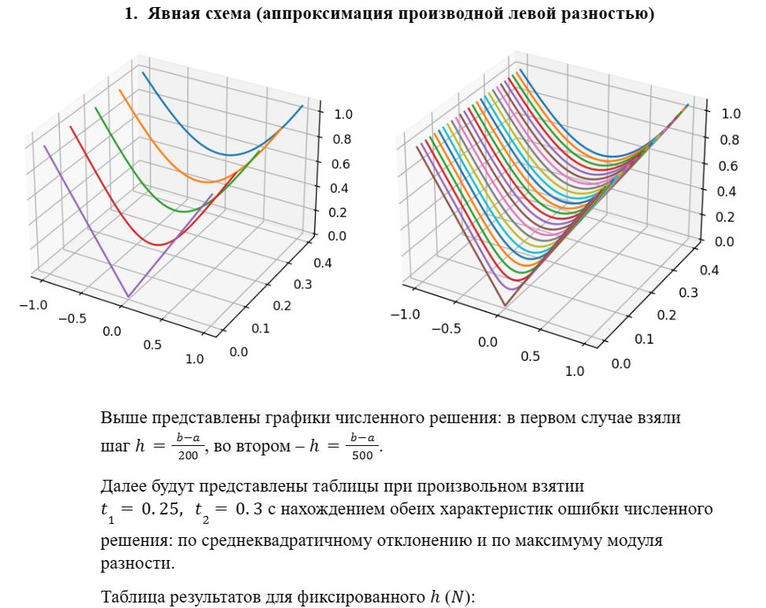

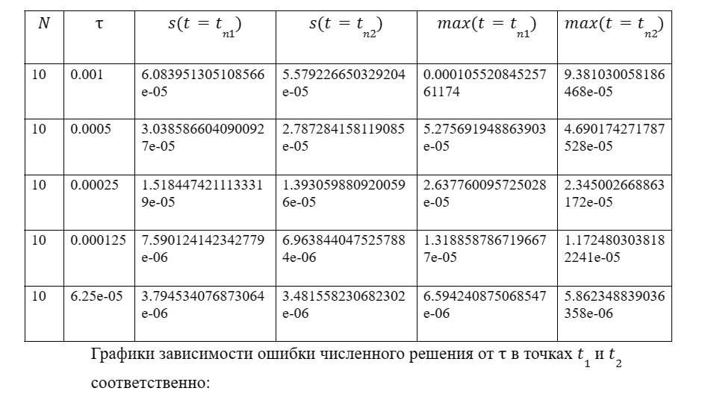

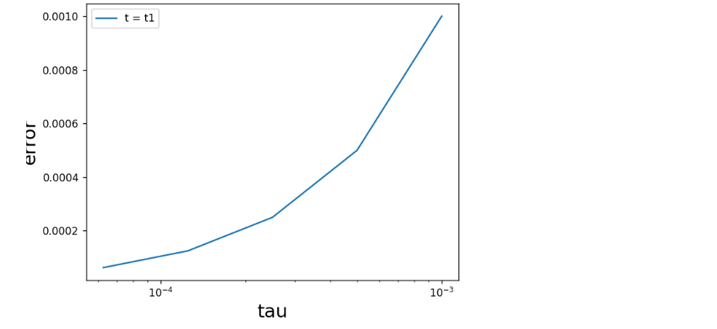

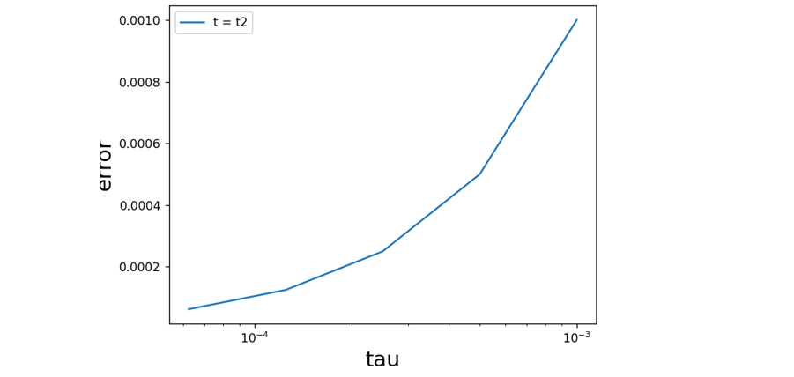

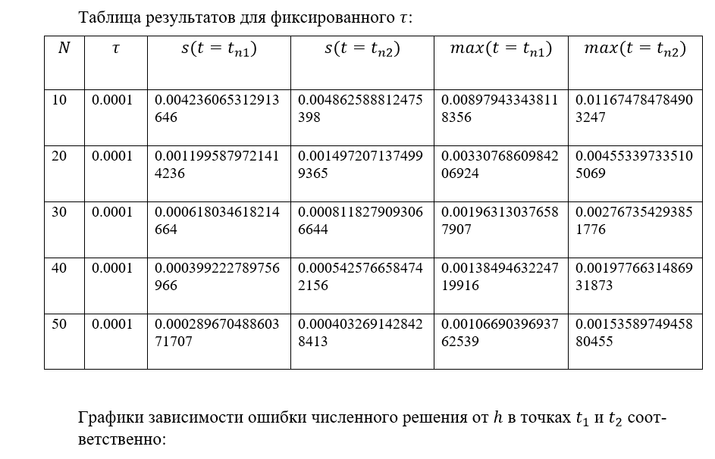

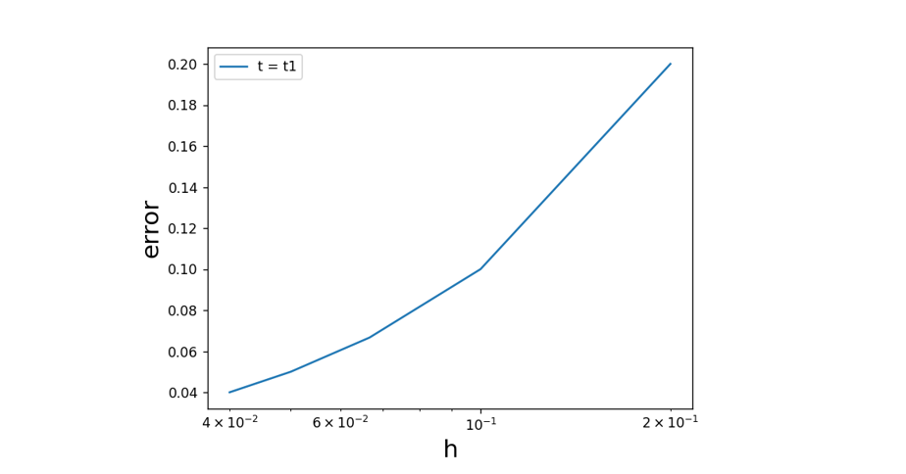

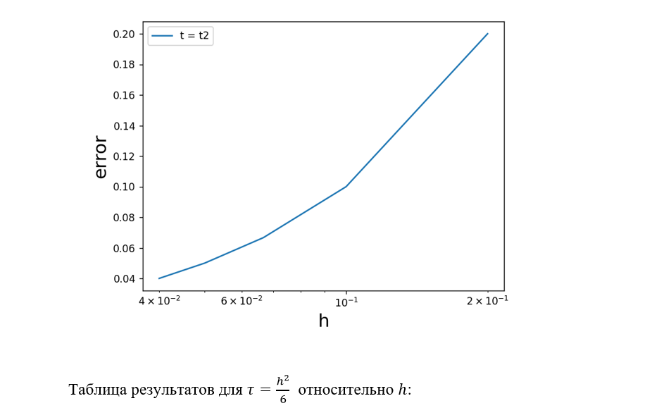

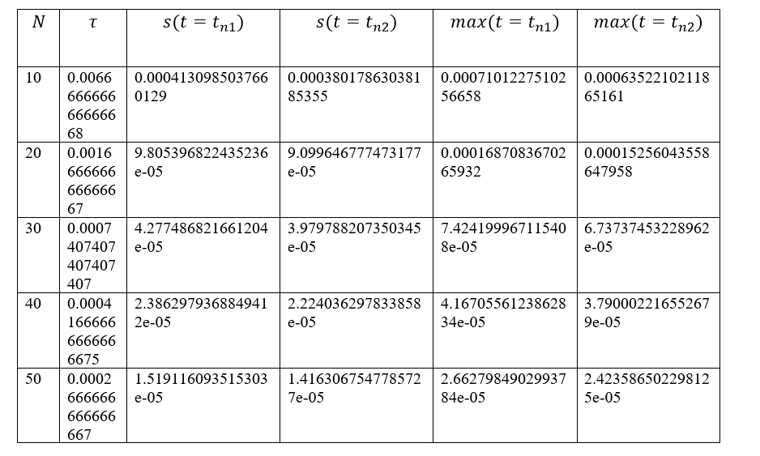

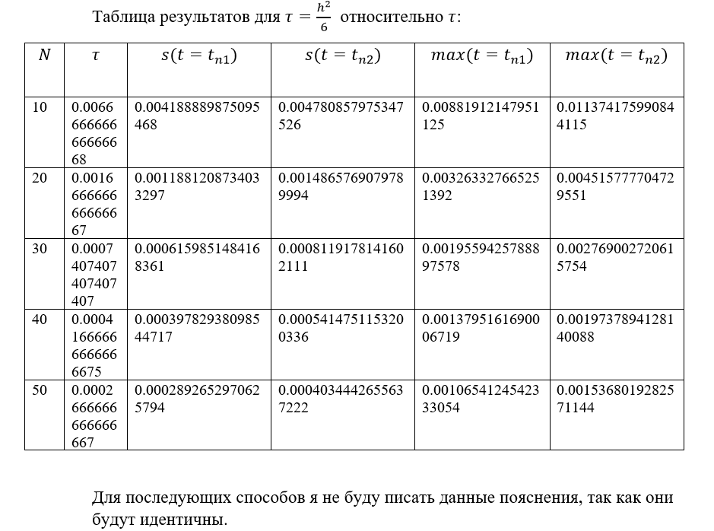

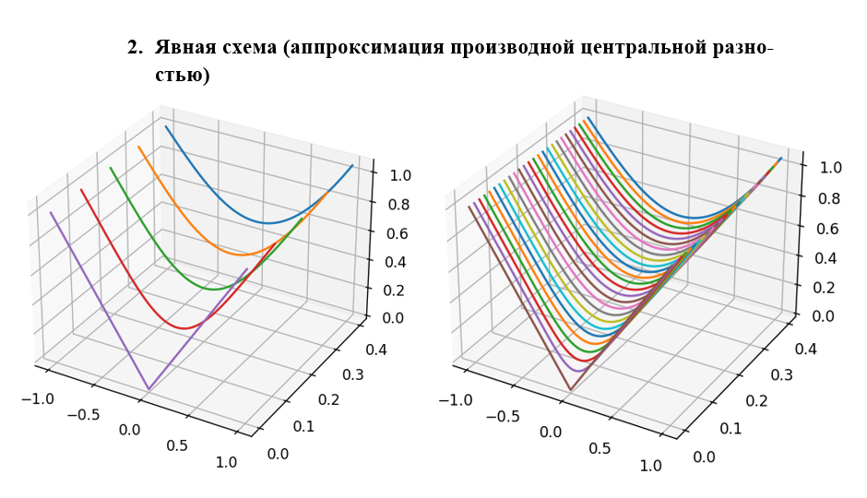

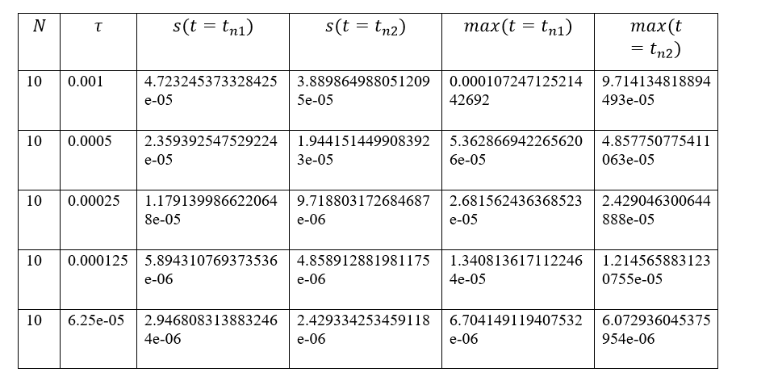

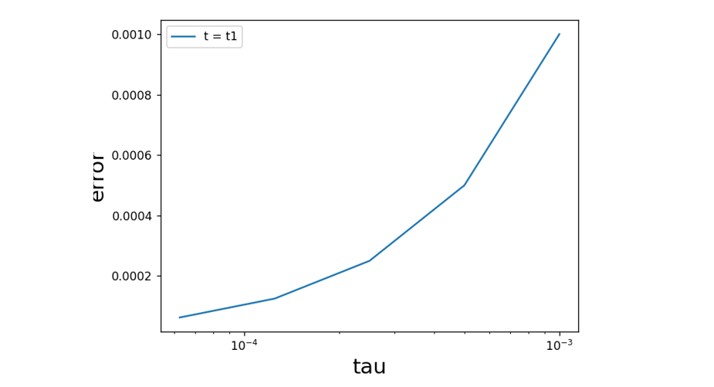

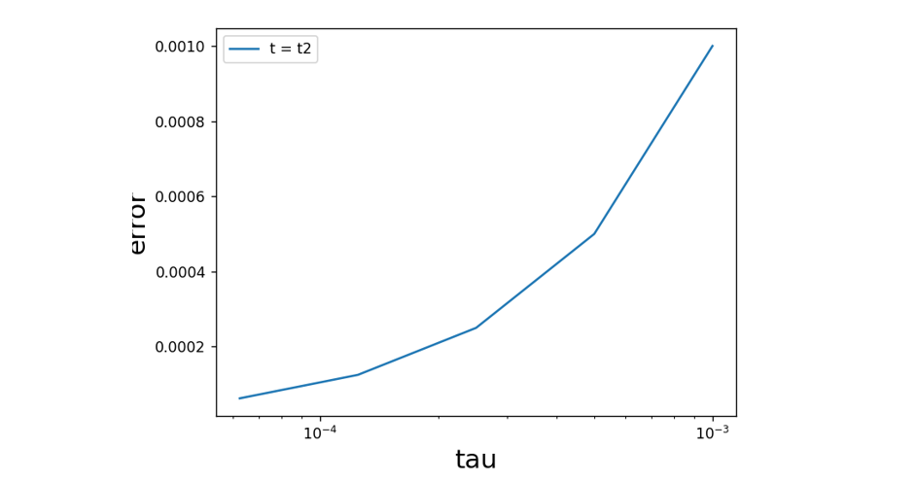

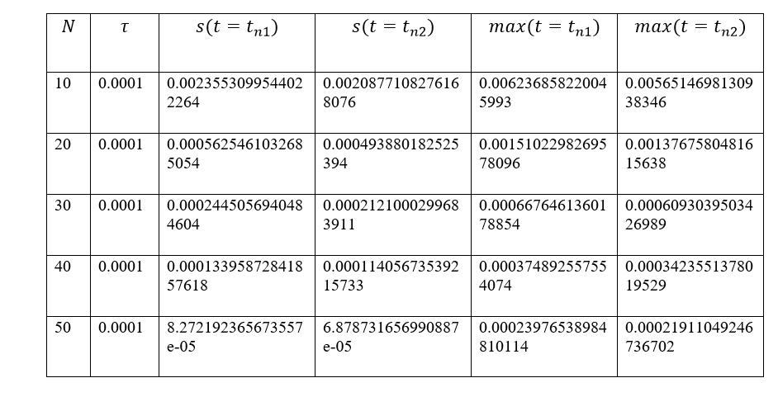

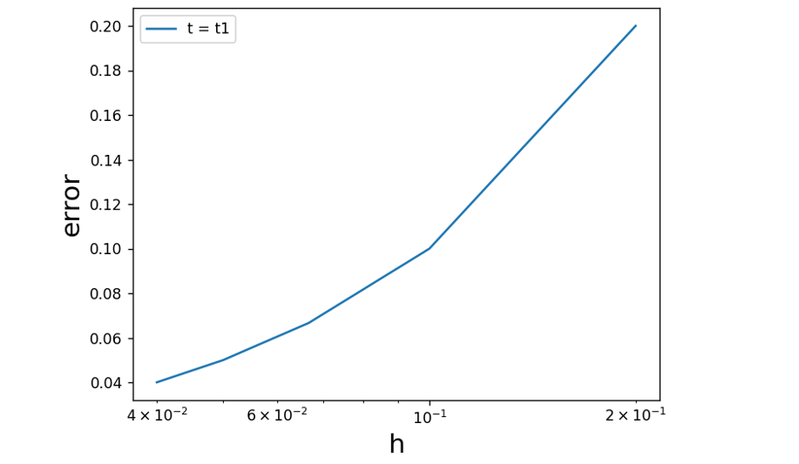

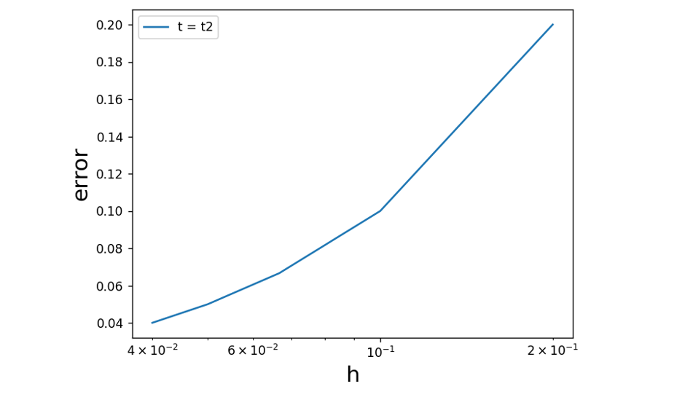

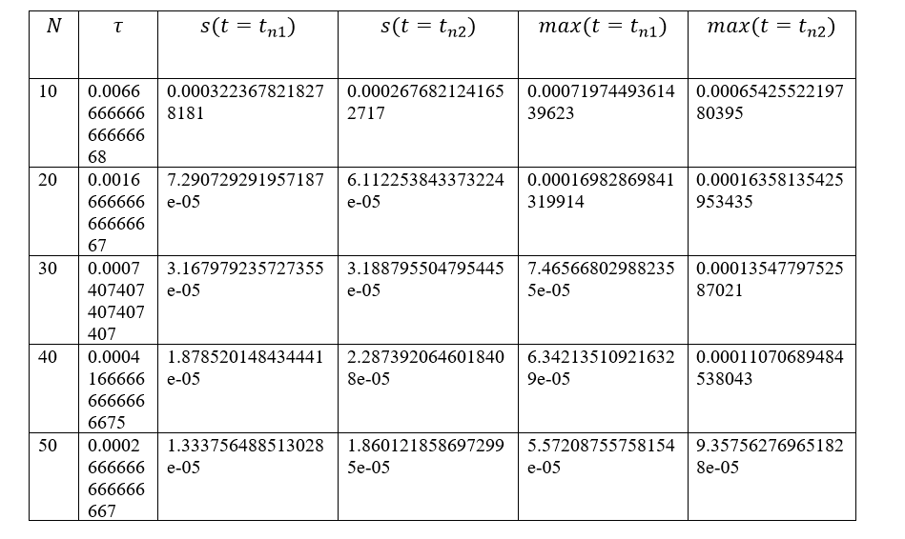

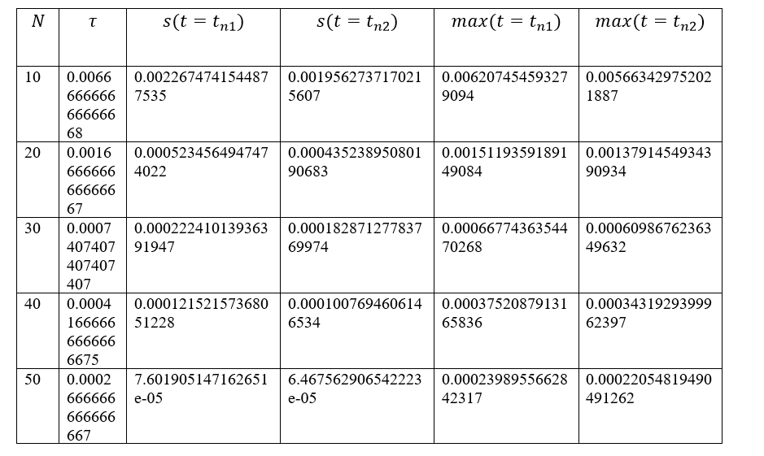

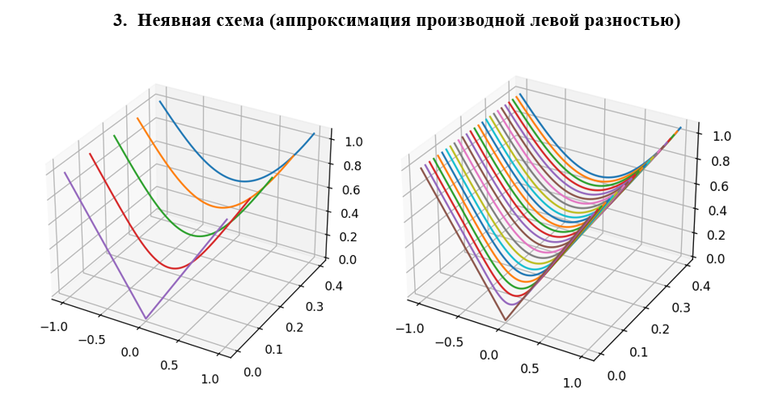

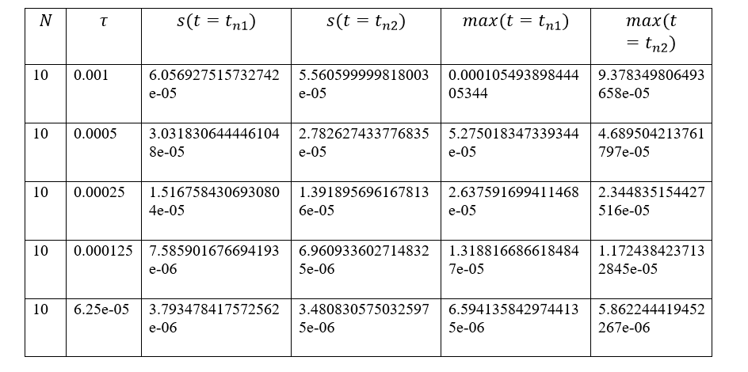

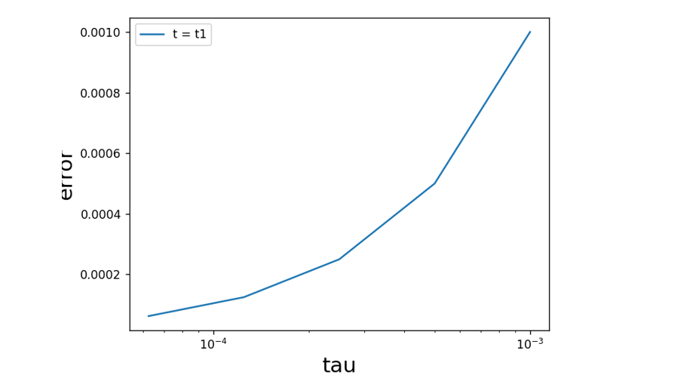

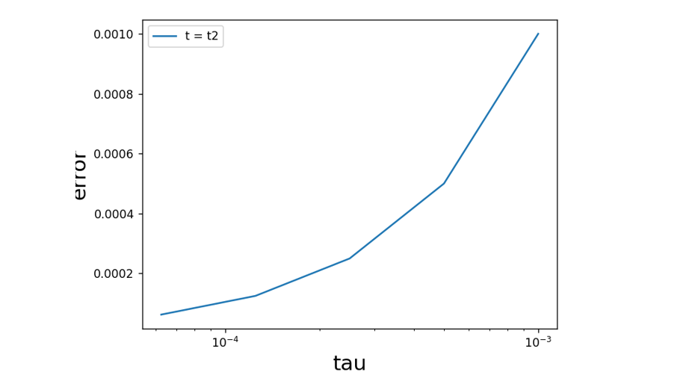

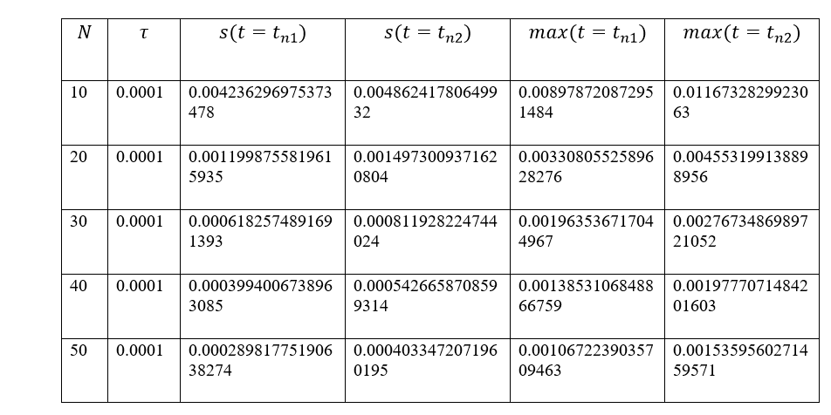

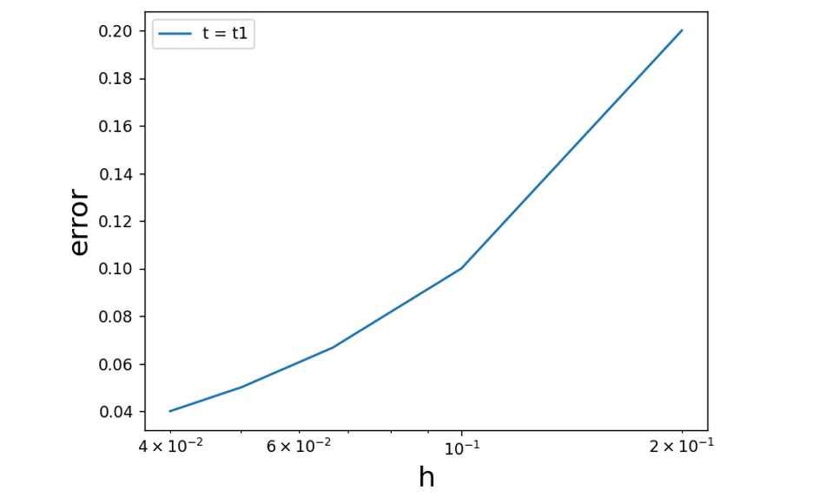

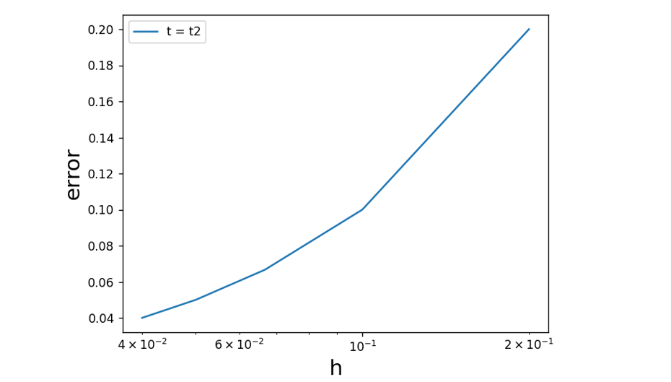

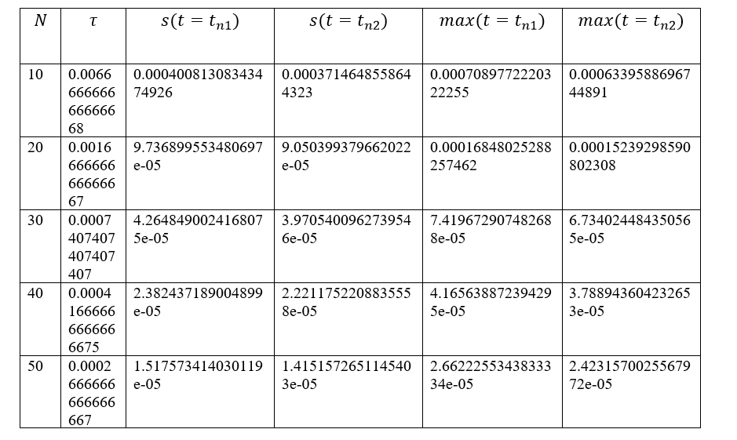

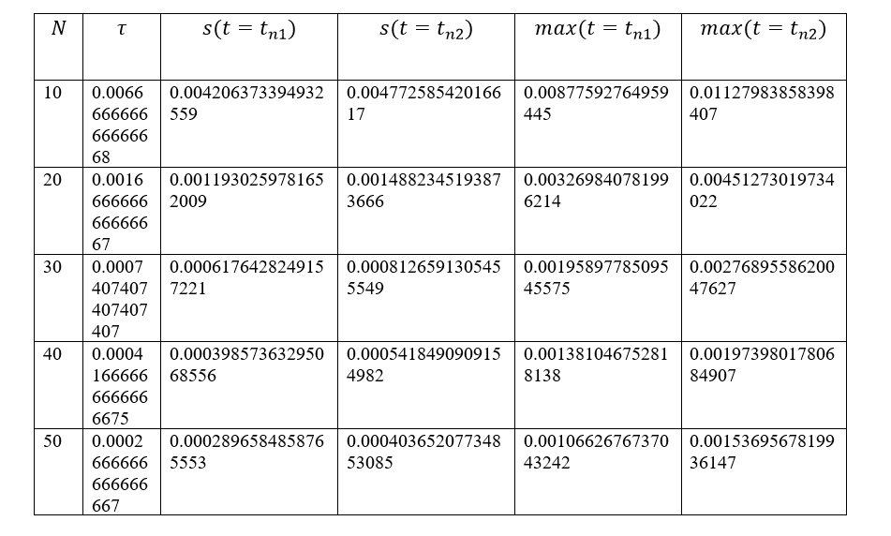

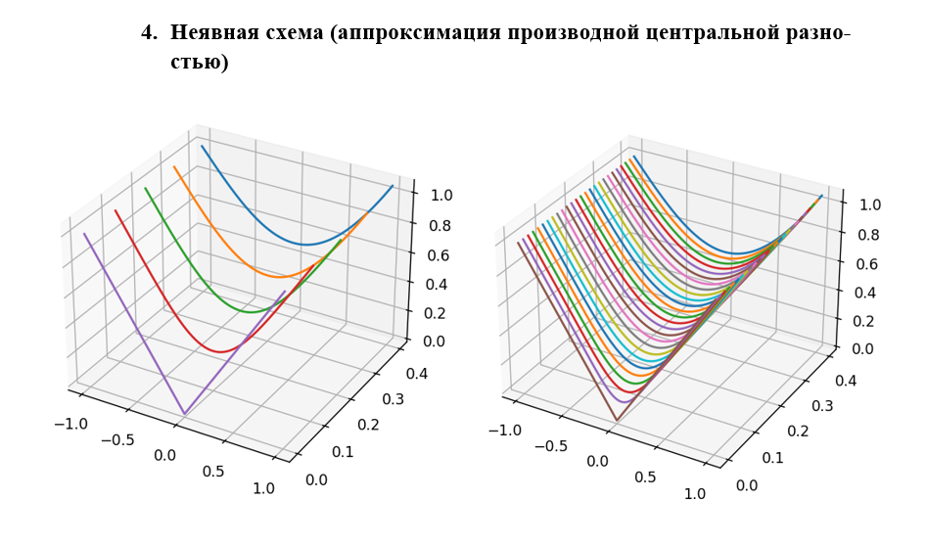

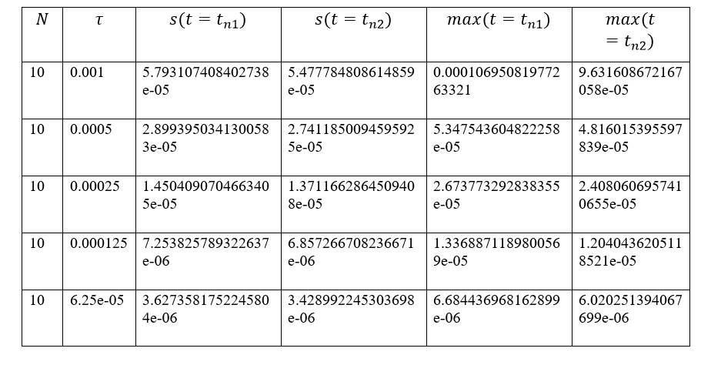

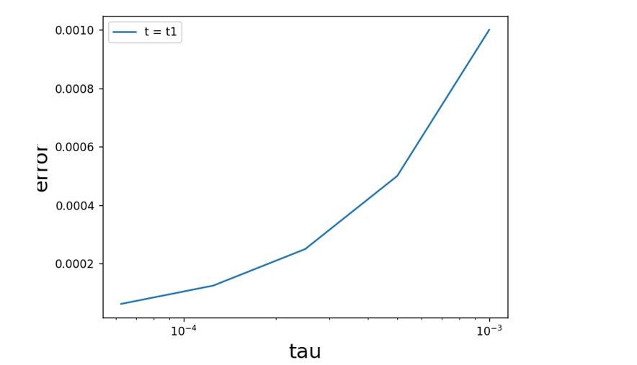

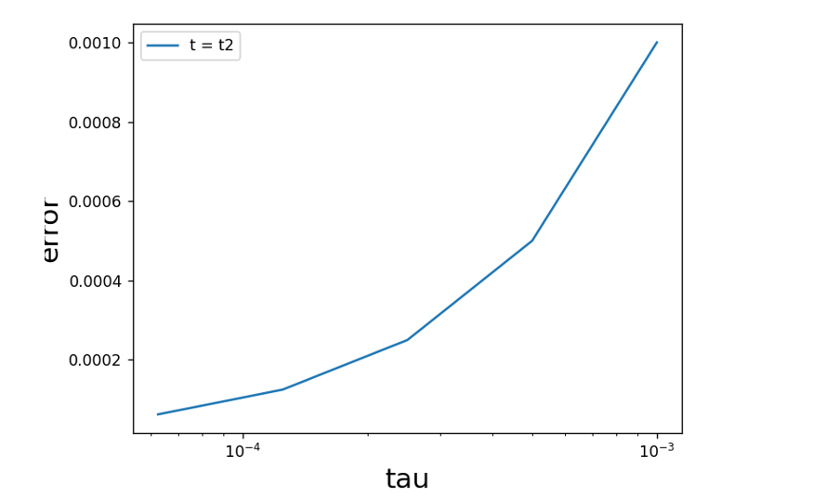

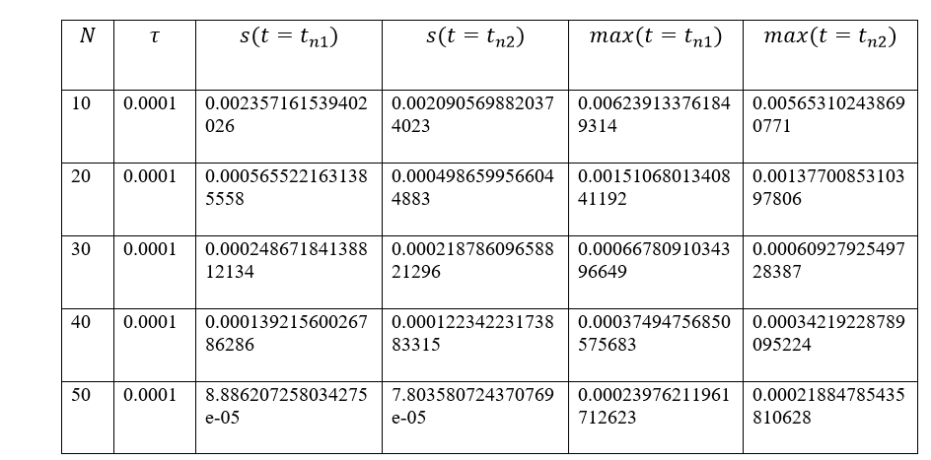

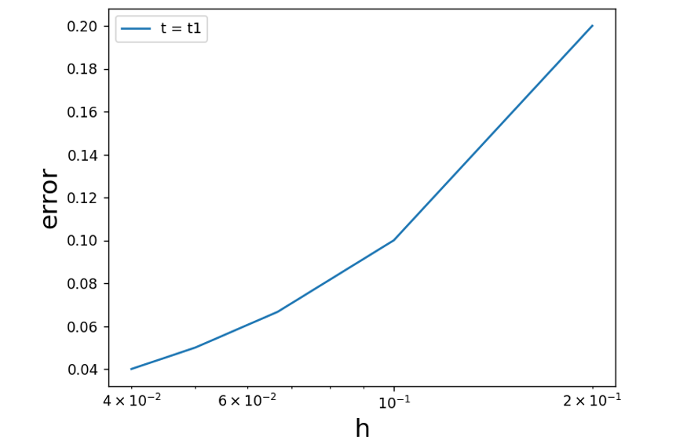

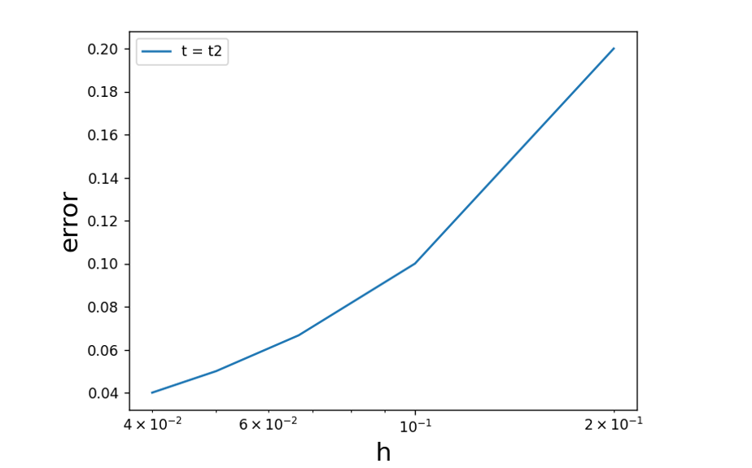

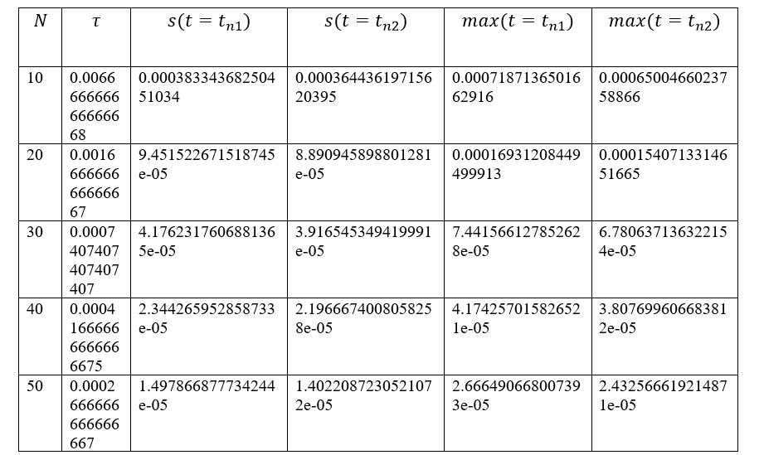

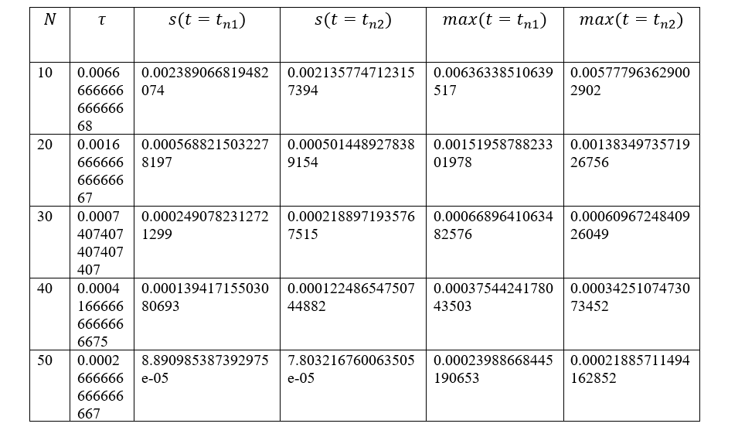

**Выводы**

